Notes on Sound test of two Mid/High Level Chinese Made Cymbal Sets:
Chang AB Stage (ABS) vs Tongxiang TZS
www.changfan.site (see site for video reviews)
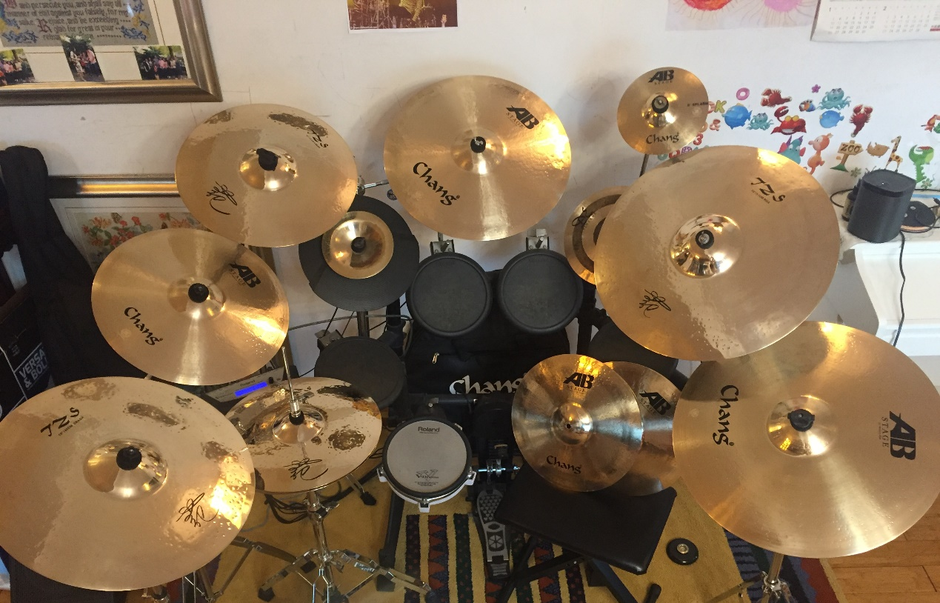
Aim and Background:

Here I was particularly looking to find better examples of Rides and Hi-Hats than I had tested in the previous tests of the Chang’s DEV and Zildjian S, but without having to splash out on big names. My aim was to test out a representative cymbal set of what these companies were offering in their higher mid ranges and was seeking versatile cymbals that were also compatible with more rocky styles in a manner that the earlier tested Chang DE Vintage (DEV) were clearly not, (the DEVs being far more suited to lighter forms of music).

These two ranges (Chang AB Stage and Tongxiang TZS) are representative sets of the mid/high range of each company. At least at a wholsesale level the Tongxiang TZS are 15-20% more expensive than the Chang AB Stage, but I was happy to consider them broadly in the same price category.

Result
Whilst being vastly different in character, both of these sets were impressive. The Rides (both) and the Hi Hat (AB Stage) represented a vast improvement in expression/tone etc than the previous Zildjian S or Chang DE Vintage. The previous Ride issues such as the lack of power and expression on the bell (DEV) were entirely (TZS) or for the most part (ABS) cured. No discordant ring (as in Zildjian S) was noted on either the ABS or the TZS though the ring on the TZS was far longer.

In addition, whilst I was delighted to find that whilst these two sets pretty much ticked every box, I was pleased and interested to discover that they were vastly different feel (as well as look) to these two cymbal sets.

Overview Chang AB Stage

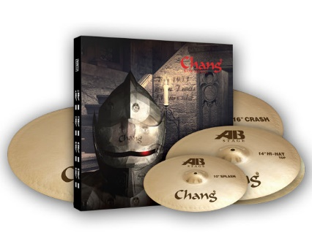
The Changs were bright versatile cymbals with tonal clarity, sweetness (ride) and in every way seemed to me fuller and, for want of a better expression, more expensive sounding, than their DEV forerunners. Chang’s own description “balance”, “all-round series”, “flexibility and variation in tone”, and “clear definition”, I would completely concur – it describes them perfectly! However, possibly in the attempt to maintain their broad versatility, they have only moved half the distance in power and penetration, (with exception of the Hi Hat and the bell on the 18”). They remain, particularly when placed alongside the TZS range, quieter and with much shorter rings or “Fast cut” as Chang accurately puts it. The snappy, crisp, balanced Hi Hat with a good measure of penetration, (more so than the rest of the kit) was a great relief. I do expect the whole set would sound fantastic which miked-up and, in this way I wonder if the “AB Stage” might be better called “AB Studio” because I feel these cymbals with their warm, versatile but still slightly delicate tones would be better picked up in a recording studio than in a Gig stetting. Certainly, in terms of heavier live forms of music, drummers might be better leaning toward Tongxiang’s TZS (see below) or Chang’s more dedicated heavy music cymbals (Chang AP or, at the higher price range, the “Immortal Brilliant” series). However for anything up to and including Alternative Rock, this set would also be a peach in a live setting, but moving up to Hard Rock and Metal – best look elsewhere.

Overview Tongxiang TZS
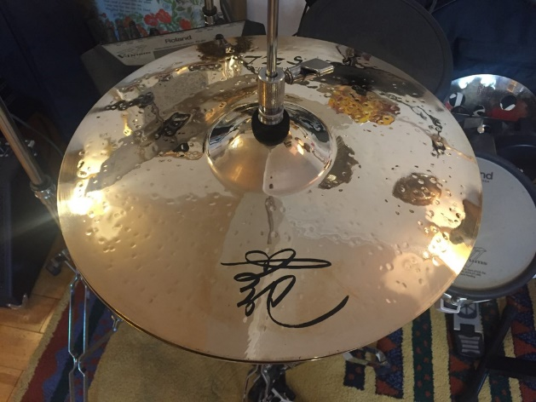
The fantastic look of these highly polished brilliant-finish cymbals is the first thing that hits you – if looks are important these shimmering around you as you play will look fantastic. In contrast to the Chang AB, the overall feel of these cymbals is more darkness, more shimmer (in look and sound!) and a far more powerful and penetrating sound than the Chang ABS. In the two objectives of these two sets, the first (versatility) is clearly awarded to the Chang ABS, the second (suitable for rock and heavier music forms), goes hands-down to the Tongxiang’s TZS with long sustain and far more power and penetration than the Changs. The 18” is a particular highlight of the kit, a fantastic shimmering low-tone crash and a similar theme runs across the kit where long-sustains and low/dark tones are the order of the day (If I have the courage, I’ll borrow a set of Zildjian K’s to test them alongside!). The only possible disappointment is the HiHat which, for me does not quite match the maturity and clear power and sound quality of the rest of the set. But overall a fantastic looking and sounding set – ideal for a gig setting.

In Short - Who wins ? (Entirely depends on what you are looking for!)
Cost= ABS
Looks = TZS
Power/penetration/volume= TZS.
Brightness and tonal clarity= ABS.
Darkness and shimmer = TZS
Versatility = ABS.
Heavy forms of Music = TZS
Lighter forms of Music= ABS
Medium/Alternative Rock = Subjective
Long Ring/Sustain/Decay = TZS.
Short Ring/Sustain/Decay = ABS.

*For reference: The Chang ABS 6-Cymbal Set is currently retailing at $379 + Postage from China [for postage, on average, add about another $100 to the U.S] *

